U.S. National Early Detection and Rapid Response System for Invasive Plants
EDRR Fact Sheet
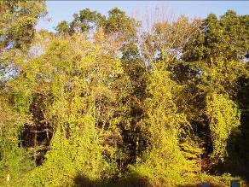
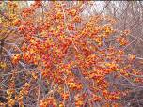
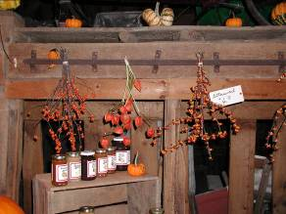
Randy G. Westbrooks, U.S. Geological Survey, Whiteville, North Carolina. USA.
Marika Godwin, Coordinator, Invasive Species Alliance of Nova Scotia. Wolfville, NS, Canada.
Common Name: Oriental Bittersweet
Scientific Name: Celastrus orbiculatus Thunb.
Family: Celastraceae
Description: A deciduous, woody, twining vine or trailing shrub, up to 60’ long, with separate male and female plants. Stems up to 4” in diameter. Leaves alternate, light green, glossy, rounded with finely toothed margins, 2-5” long. Flowers small, greenish, in clusters at leaf axils along the stem, spring to early summer. Fruit a globular bright yellow berry, splitting open at maturity to reveal three red arils (specialized growth that covers the seeds), each with 1-2 seeds. Outer root surface is typically bright orange.
American bittersweet (Celastrus scandens L.), which is similar, has leaves that are twice as long as Oriental bittersweet leaves, and are tapered at each end. The flowers and fruits occur in clusters at the tips of the stems (left side of image).
Images: Oriental Bittersweet in Connecticut. Les Mehrhoff, UCONN.
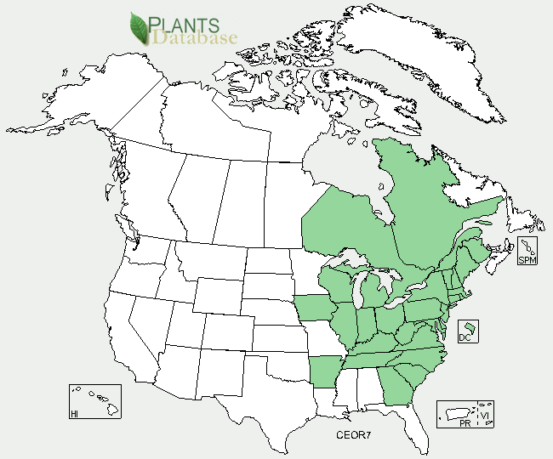
Habitat: Oriental bittersweet is often found in old homesteads, gardens, open fields, fencerows, salt marsh and forest edges. It is tolerant of shade, which allows it to invade forested areas.
Native Range: Eastern Asia, Japan, Korea and China.
Pathways of Introduction and Spread: Oriental bittersweet was introduced to the U.S. as an ornamental vine in the 1860s. In spite of its invasive characteristics, it is still harvested and used in making ornamental displays. The plant is also dispersed by birds that eat the fruits, and vegetatively through root suckering.
U.S. and Canada Distribution:
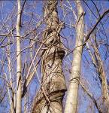
Ecological and Economic Impacts: Oriental bittersweet vine can totally cover low growing vegetation and kill it by shading and breakage. It forms a large mass of vines high in trees which makes them top heavy, which can lead to uprooting during wind storms. This also makes trees more vulnerable to breakage during heavy snowfalls. The prolific vines encircle a tree and can eventually girdle and kill it.
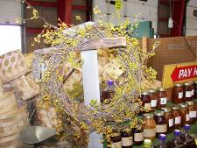
Image: Oriental bittersweet girdling a tree in Connecticut. Les Mehrhoff, UCONN.
In spite of being listed as a state noxious weed in North Carolina, mountain crafters continue to use Oriental bittersweet in making decorative wreaths. However, American bittersweet has similar fruits and could be used to make colorful wreaths as well. In the northeastern U.S., Oriental bittersweet is displacing American bittersweet, which occurs in similar habitats, through competition and hybridization.
Image: Oriental Bittersweet Wreath - Farmer’s Market, Asheville, N.C. September 14, 2008.
Manual Removal: Hand pulling and removal are only effective on young plants and small infestations. To do this, the vines should be repeatedly cut back and the root system pulled up until the food reserves in the roots are exhausted.
Chemical Treatments. Chemical treatment of Oriental bittersweet foliage is best done when surrounding native plants are dormant. When practical, the site can be mowed early in the season, and treated with a herbicide as the foliage starts to grow back. For small infestations, the top vines should be cut and removed. Following this, cut surface of the rooted stems should be painted or sprayed with triclopyr (Garlon - a brush killer) or glyphosate (Roundup and others). Treated areas should be continually monitored and addressed for seedling germination and regrowth of mature vines.
Regulatory Status: Oriental bittersweet is regulated as a state noxious weed in Connecticut, Massachusetts, New Hampshire, North Carolina, and Vermont. In North Carolina, it is regulated as a Class C State Noxious Weed.
Native Alternatives: American Bittersweet (Celastrus scandens), Trumpet honeysuckle (Lonicera sempervirens), Trumpet creeper (Campsis radicans), passionflower vine (Passiflora lutea), Dutchman’s pipe (Aristochloa microphylla) and Native wisteria (Wisteria frutescens).
Online Resources:
Oriental Bittersweet Fact Sheet – Plant Conservation Alliance.
URL: http://www.nps.gov/plants/alien/fact/ceor1.htm
Oriental Bitter Sweet Images - U-GA Bugwood Image Gallery.
URL: http://www.invasive.org/species/subject.cfm?sub=3012
Oriental Bittersweet Profile - USDA Plants Database.
URL: http://plants.usda.gov/java/profile?symbol=CEOR7

