U.S. National Early Detection and Rapid Response System for Invasive Plants
EDRR Fact Sheet
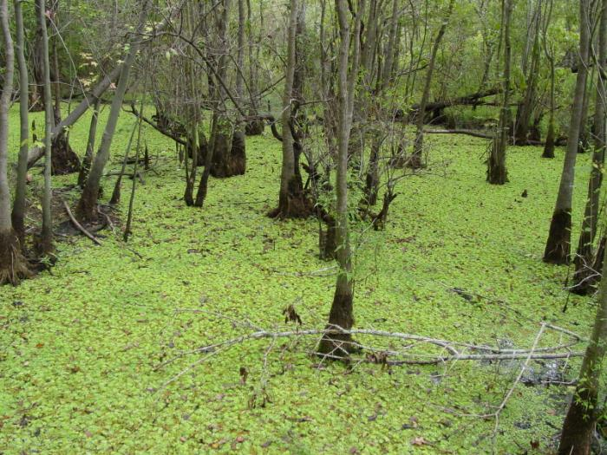
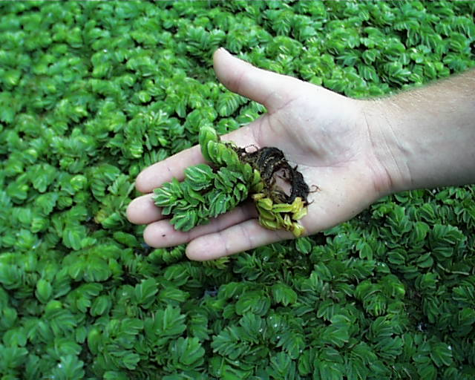
Randy G. Westbrooks, U.S. Geological Survey. Whiteville, North Carolina. USA.
Brittany Cartrette, Southeastern Community College. Whiteville, North Carolina. USA.
Common Name: Giant Salvinia, Kariba weed
Scientific Name: Salvinia molesta D.S. Mitchell
Family: Salviniaceae
Description: A free floating aquatic fern with a horizontal rhizomes (lies below the water surface) and two types of fronds in whorls of three (2 floating and 1 submerged). Floating fronds are positioned opposite to each other on the plant stem, up to 1.5” long, oblong in shape, with a distinctive fold in the center, and vary in color from light green to golden brown. Upper surface of the floating frond has rows of ‘egg-beater’ tipped hairs that trap air and enable the plant to float. Submerged fronds function in water and nutrient uptake. The mature plant produces egg-shaped spore sacs containing infertile spores. Reproduction is by stem fragmentation and budding.
Image: Giant Salvinia in the River Bend Swamp, Pender County, N.C. September, 2002. Images by R. Westbrooks.
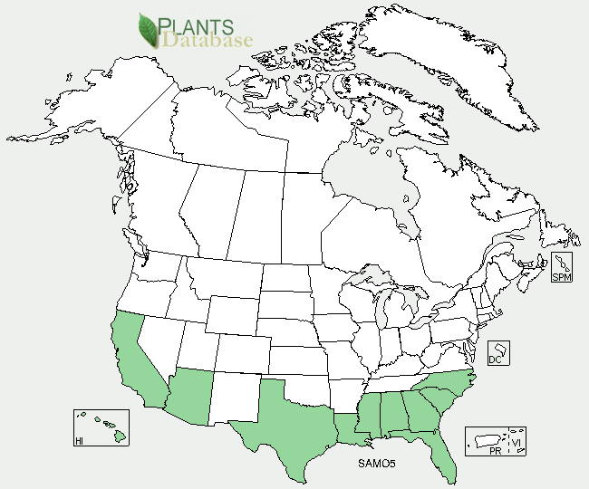
Habitat: Giant Salvinia can invade almost any kind of freshwater system. It prefers tropical, sub-tropical, or warm temperatures, and grows best in nutrient rich still or slow-moving waters such as ditches, canals, ponds, lakes, and rivers. It grows best at a water temperature of 68-86º F. It can only tolerate salinity levels of 10% that of seawater.
Native Range: Southeastern Brazil and northeastern Argentina.
Pathways of Introduction and Spread: Giant Salvinia was first imported by the pet trade to be used in aquariums and garden ponds. Since then, it has escaped into the wild. Once in a waterway, it is spread by flowing water, as well as boats and other equipment into new areas.
U.S. and Canada Distribution:
Ecological and Economic Impacts: Giant Salvinia is one of the worst weeds in the world. It only takes a single small plant to form a floating mat called ‘sudd’ on the surface of standing water – up to 3’ thick. The mats clog and prevent access to waterways, and block out sunlight which is needed by algae and other aquatic plants for photosynthesis. This leads to oxygen depletion of infested waters. As it dies and decays, decomposers use up even more of the oxygen in the water. It also prevents the natural exchange of gases between the water and the atmosphere – which leads to stagnation of the water body. Ultimately, this will kill any plants, insects, or fish that are living under the mats. The mats also provide ideal conditions for breeding of mosquitoes that carry disease.
Preventative Measures: Prevention is the most important strategy for managing Giant Salvinia. Once it becomes established and widespread in a water body, it is very difficult to control. Under ideal conditions, it can double its mass in 5-7 days, if not quickly addressed. On a local level, a monitoring program should be instituted to ensure that Giant Salvinia is detected and quickly addressed if it is accidentally introduced into a water body. Boat and trailer inspections, as well as signage at boat ramps will help to raise awareness of the problem.
Manual and Physical Control: Large infestations may be mechanically harvested to open up access to a water body. However, removal operations in large waterways should be followed by chemical treatment to minimize regrowth of remaining plants. Infestations in small water bodies may be removed by hand, or by draining the water and allowing the plant to desiccate.
Chemical Control: A number of herbicides are effective in controlling Giant Salvinia plants. Examples include diquat (Reward – a contact herbicide) and fluridone (Sonar – a systemic herbicide taken up from the water column). It is important to remember that contact herbicides such as diquat will control only the plants that it touches. Systemic herbicides such as fluridone are ideal for controlling salvinia in small, contained water bodies with standing water. All of the plants with submerged fronds will take up the chemical from the water and be killed. However, it will not stay concentrated in large, open water bodies and flowing waterways.
Biological Control: In some places, biological control is the most effective method for managing Giant Salvinia. A good example is the South American Salvinia weevil (Cyrtobagous salviniae), which showed excellent results in controlling Salvinia on Lake Moondarra in Queensland, Australia, in the early 1980s, and elsewhere. However, biological control is NOT a panacea for managing Giant Salvinia. In spite of its success in controlling Giant Salvinia in some places, the Salvinia weevil was not successful in controlling Salvinia in Kakadu National Park in the Northern Territory of Australia. This is because the potential ecological range of a biological control agent is sometimes not the same as the weed being controlled. Sometimes, the agents will not survive and reproduce in new regions in which the target plants are adapted.
Regulatory Status: Giant Salvinia is listed as a U.S. Federal Noxious Weed. It is regulated as a state noxious weed in Alabama, Arizona, California, Colorado, Connecticut, Florida, Massachusetts, Mississippi, Nevada, North Carolina, Oregon, South Carolina, Texas, and Vermont.
Online Resources:
Giant Salvinia Image - U-GA Bugwood Image Gallery.
URL: http://www.invasive.org/species/subject.cfm?sub=2785
Giant Salvinia Profile – ISSG Global Invasive Species Database.
URL: http://www.issg.org/database/species/ecology.asp?si=569&fr=1&sts=sss
Giant Salvinia Profile - USDA Plants Database.
URL: http://plants.usda.gov/java/profile?symbol=SAMO5

