U.S. National Early Detection and Rapid Response System for Invasive Plants
EDRR Fact Sheet
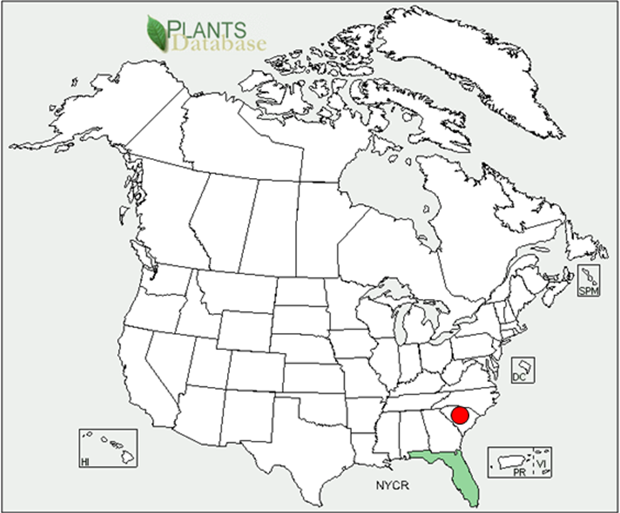
Randy G. Westbrooks, U.S. Geological Survey. Whiteville, North Carolina. USA.
Larry McCord, Santee Cooper, Moncks Corner, South Carolina. USA.
Common Name: Crested Floating Heart
Scientific Name: Nymphoides cristata (Roxb.) O. Ktze.
Family: Menyanthaceae
Description: An herbaceous aquatic plant with floating stems from a buried rootstock. Slender tuberous roots dangle from the stem-leaf node. A Single Heart-shaped Leaf with smooth margins, cordate base, and short petiole at the tip of each stem. Flowers white, with membranous margins, 0.3-0.9” wide, petal lobes with a ruffled crest (like a rooster’s comb) along the upper midvein, blooming from summer to fall. Fruit an oblong capsule, with smooth, rounded seeds.
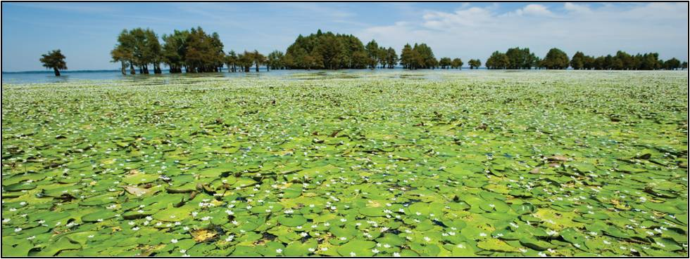
Plant Images: Crested Floating Heart on Lake Marion, South Carolina. Photos courtesy of Jim Huff, Santee Cooper, Moncks Corner, South Carolina.
Similar Plants: Big Floating Heart (N. aquatica), Little Floating Heart (N. cordata), and Water Snowflake (N. indica).
Habitat: Crested floating heart grows in ditches, canals, ponds, and lakes.
Native Range: Asia.
Pathways of Introduction and Spread: Crested floating heart was first introduced to the U.S. as a water garden plant. Once established in a waterway, fragments of the plant are spread by wind, flowing water, boats, and trailers.
Crested Floating Heart in Florida: Free living populations of Crested floating heart were first observed in cypress swamps and water management canals in southeast Florida in the late 1990s. Within a few years, large canals and suburban lakes in the central and eastern parts of the state had become infested. There is serious concern about this plant because herbicides that control other floating and emergent invasive plants have had little effect on it. It is still being sold in the water garden trade.
Crested Floating Heart in South Carolina: Crested floating heart was first detected in a 20 acre cove near Eutaw Creek at the southeastern end of Lake Marion (Orangeburg County), South Carolina, in August, 2006. This was the first time that free living populations of the plant had been found outside of Florida. The plant was most likely introduced into the Santee Cooper Lake System (Lake Marion and Lake Moultrie) from backyard water gardens, or by recreational boaters. Initial applications of herbicides that control other aquatic weeds were largely ineffective – as already seen in Florida. Low water levels experienced during of 2007-2008, as well as freezing winter temperatures also had little effect on the plant. By mid-2007, about half of the cove at Eutaw Creek was covered by the plant. By late 2008, the plant had spread to other areas of the lake, both downstream and upstream from the original infestation. In 2009, it was estimated that about 2,000 surface acres of Lake Marion are infested with the plant. It has also been found in nearby Lake Moultrie, as well as the Santee River below the Lake Marion dam. Crested floating heart has also been detected in a golf course pond on Pawleys Island, South Carolina (Jack Whetstone, Clemson University, Georgetown, South Carolina. Personal Communication, May 19, 2010).
Control Strategies: In October, 2009, Santee Cooper aerially sprayed 350 surface acres of Lake Marion that had become infested with the plant. Currently, Santee Cooper is using a tank mix of glyphosate (Touchdown Pro) plus imazamox (Clearcast), combined with TopFilm (a pesticide adjuvant/sticker), or the surfactant AquaBuph, in efforts to control Crested floating heart. Santee Cooper has also found that endothall (Aquathol K) provides short term control of the plant in enclosed water bodies with still water. Early results from the 2009 treatment effort show a small reduction in total surface acres infested in the Santee Cooper lakes.
The Role of Volunteers in Detection and Reporting of Crested Floating Heart: Based on suitable habitat for the plant, biologists estimate that Crested floating heart could ultimately infest as much as 40% of the 160,000 acre Santee Cooper Lake System if it is not controlled. Therefore, in 2010, Santee Cooper is planning to conduct early detection and delimiting surveys across the lake system, and will conduct additional treatments, based on the effectiveness of the 2009 control program. However, surveys are also needed on the Santee River and on area golf courses. At this point, it is critical that preventative measures be taken by boaters and water garden enthusiasts to minimize the spread of this new invader. New infestations should be reported to state officials, and eradicated to prevent further establishment and spread. This is a good example of the field work that EDRR volunteers could do to assist agencies such as SC-DNR and Santee Cooper in their efforts to detect and manage new invasive species such as Crested floating heart.
Regulatory Status: Crested floating heart is not currently being regulated anywhere in the U.S.
Online Resources:
Crested Floating Heart in Lake Marion, South Carolina. Southeast Exotic Pest Plant Council – EDDMapS. URL: http://www.eddmaps.org/southeast/distribution/point.cfm?id=633409
Crested Floating Heart Profile – U-FL Center for Aquatic and Invasive Plants.
URL: http://plants.ifas.ufl.edu/node/291
Crested Floating Heart Supplier – The Water Garden, Chattanooga, TN.
URL: http://www.watergarden.org/Pond-Supplies/Lily-like-Aquatics/White-Snowflake

Florida’s Floating Heart Fact Sheet – Comparison of the Four Floating Heart Species that Occur in Florida. Colette Jacono, U.S. Geological Survey, Gainesville, Florida.
URL: http://plants.ifas.ufl.edu/misc/pdfs/nymphoides.pdf

New Nymphoides in Lake Marion. S.C. Aquatic Plant Management Society Newsletter. 28(1):3. URL: http://www.scapms.org/images/may2007news.pdf

Santee Cooper plans aerial spraying to fight invasive lilies. The DigitelCharleston. 10-1-2009.
URL: http://charleston.thedigitel.com/green/santee-cooper-plans-aerial-spraying-fight-invasive-6353-1001

Draft Date: May 19, 2010.

