U.S. National Early Detection and Rapid Response System for Invasive Plants
EDRR Fact Sheet
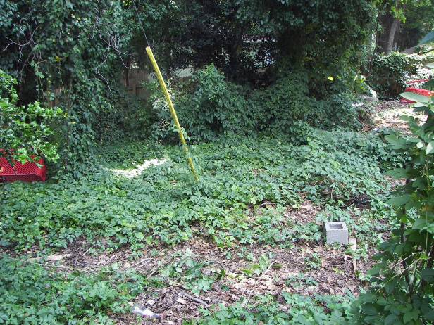
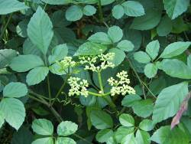
Randy G. Westbrooks. U.S. Geological Survey, Whiteville, North Carolina. USA.
Marika Godwin, Coordinator, Invasive Species Alliance of Nova Scotia. Wolfville, NS, Canada.
Common Name: Bushkiller, Sorrel Vine
Scientific Name: Cayratia japonica (Thunb. ex Murray) Gagnep.
Family: Vitaceae
Description: A perennial, twining vine, up to 40’ long. Leaves pedately compound with 5 leaflets [the lateral leaflets (two per side) form a small pinna on each side of the leaf], alternately arranged on the main stem, margins toothed, tendrils opposite from each leaf. Flowers in umbels, salmon/orange, cup-shaped, late summer. Fruit a white or black berry, with 2-4 triangular shaped seeds.
Image: Bushkiller infestation in Charlotte, North Carolina. June, 2007. Image by R. Westbrooks.
Note: In its native range, Bushkiller reproduces by seeds and vegetative fragments. However, fruiting has not been documented in North America. Vegetative reproduction apparently occurs by root fragments and adventitious roots when the roots are cut or disturbed.
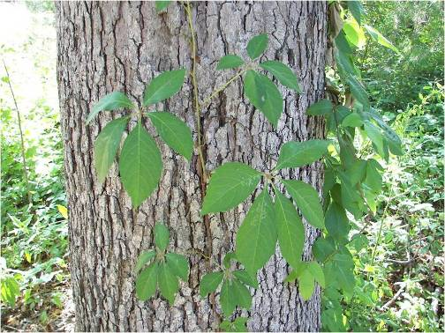
Similar Native Species: Virginia creeper (Parthenocissus quinquefolia) has palmately compound leaves, and has blue berries.
Image: Virginia creeper with palmate leaves.
Image by R. Westbrooks.
Habitat: Bushkkiller tolerates shade and full sun. It grows in damp deciduous riparian areas, developed and cultivated areas, and gardens.
Native Range: Southeast Asia, Australia.
Pathways of Introduction and Spread: Bushkiller was probably introduced as an ornamental vine. It was first collected outside of cultivation in Louisiana in 1964.
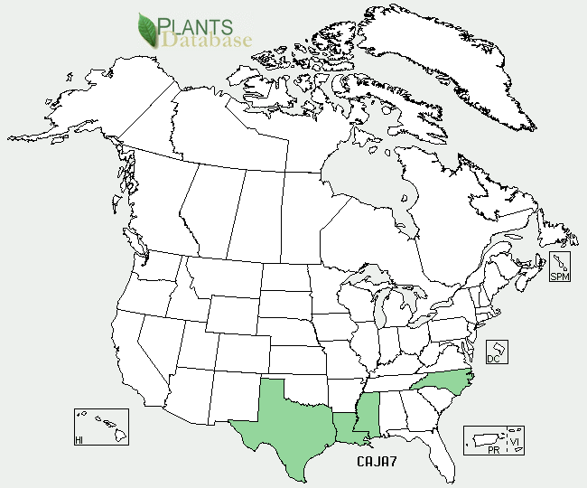
U.S. and Canada Distribution:
Ecological and Economic Impacts: Bushkiller climbs up and over other plants, and forms a dense canopy that blocks out sunlight. The canopy also causes supporting plants to be top heavy and susceptive to uprooting in windstorms, and breakage during heavy snowfalls.
Control Strategies: Bushkiller is difficult to control once it becomes established. A three year chemical effort at the Mercer Botanic Garden in Texas has only reduced the infestation by 30%. Manual removal may be an option. However, pulling and digging it out should be continued over an extended period of time to further spread and to exhaust the energy reserves in the root system.
Regulatory Status: Bushkiller is regulated as a Class B state noxious weed in North Carolina.
Native Alternatives: Virginia Creeper (Parthenocissus quinquefolia).
Online Resources:
Bushkiller Images - U-GA Bugwood Image Gallery.
URL: http://www.invasive.org/species/subject.cfm?sub=13557
Bushkiller Profile - Bugwood Wiki.
URL: http://wiki.bugwood.org/Cayratia_japonica
Bushkiller Profile – Invasive Plant Atlas of the Midsouth (IPAMS).
URL: http://www.gri.msstate.edu/ipams/Species.php?SName=&CName=Bushkiller
Bushkiller Profile - USDA Plants Database.
URL:http://plants.usda.gov/java/profile?symbol=CAJA7
Bushkiller Profile - Native Woody Plants of Arkansas (Henderson State University).
URL: http://www.hsu.edu/default.aspx?id=6367

