U.S. National Early Detection and Rapid Response System for Invasive Plants
EDRR Fact Sheet
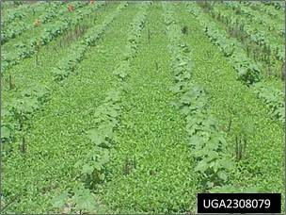
Randy G. Westbrooks, U.S. Geological Survey. Whiteville, North Carolina. USA.
Common Name: Benghal Dayflower, Tropical Spiderwort
Scientific Name: Commelina benghalensis L.
Family: Commelinaceae
Description: An annual or perennial herb. Stems creeping or ascending, succulent, 5-15” long, branched, rooting at the nodes. Leaves alternate, ovate to elliptic. Leaf sheaths often with red hairs at the apex. Bracts subtending the flower funnel-shaped. Aerial flowers lilac or blue, petals very small. Subterranean flowers whitish, cleistogamous (unopening, self pollinating), arising from basal shoots. Fruit a capsule with two seeds. Seeds ribbed, grayish-brown, very small.
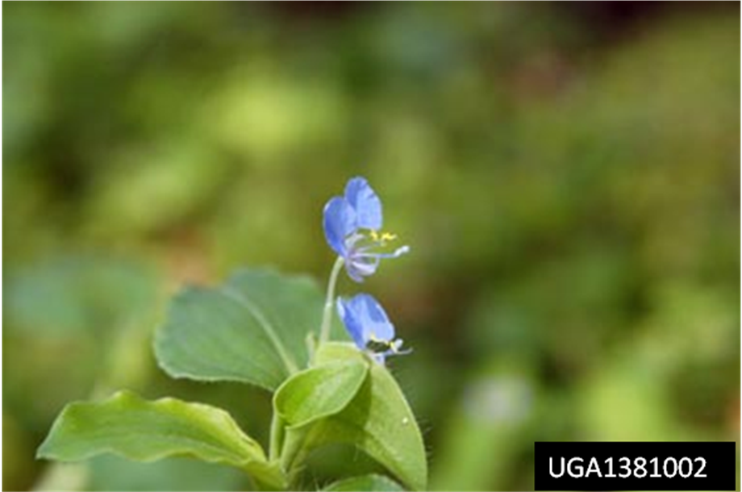
Image: Benghal dayflower in cotton.
Habitat: A weed of moist places, roadsides, waste places, along dikes, on banks of irrigation ditches, in cultivated fields, around field borders, in wet pasturelands, gardens.
Native Range: Asia and Africa.
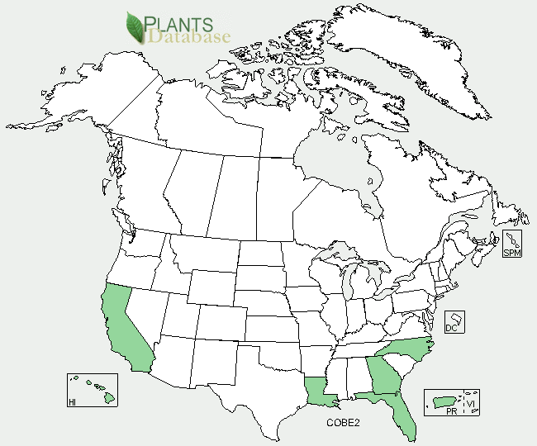
Pathways of Introduction and Spread: Benghal dayflower was introduced to the U.S. as a contaminant of seeds, spices and other condiments. It was also probably introduced as a general hitchhiker on various types of imported cargo and commodities. It was first
detected in the U.S. in 1963.

U.S. and Canada Distribution:

Ecological and Economic Impacts: Benghal dayflower is considered to be one of the worst weeds in the world. It affects at least 29 crops in 25 countries. It is also an alternate host of the nematode Meloidogyne incognita, and the groundnut rosette virus. The plant reproduces by seeds and stolons. One plant can produce as many as 1,600 seeds. It is a special problem in fields and pastures where it forms dense stands that crowd out other low growing crops and grasses.
The tremendous increase in the presence of Benghal dayflower in the southeastern U.S. since the mid-1990s has been associated with a number of major changes in cropping systems. Among these changes are the elimination of cultivation as a method for weed control (which leads to total dependence on chemical control methods), a reduction in the use of pre-emergence herbicides with soil residual activity in cotton crops, reliance on glyphosate for weed control in glyphosate resistant crops (which does not control Benghal dayflower very well), and a large increase in cotton acreage in Georgia (primarily due to eradication of the boll weevil).
Control Strategies: Prevention, early detection, and rapid response are critical in preventing the establishment and spread of this invasive plant. Mechanical control of the plant is usually ineffective because broken pieces of the stem readily root at the nodes and continue growing. Many herbicides are ineffective against the weed. This is because the seeds continue to germinate after the first flush of summer weeds and because seeds are produced aerially and underground as well.
Regulatory Status: Tropical spiderwort is listed as a U.S. Federal Noxious Weed. It is regulated as a state noxious weed in Alabama, California, Florida, Massachusetts, Minnesota, North Carolina, Oregon, South Carolina, and Vermont.
Online Resources:
Benghal Dayflower Domestic Pest Evaluation – USDA APHIS PPQ.
URL: http://www.invasive.org/eastern/other/dayflower.html

Benghal Dayflower Fact Sheet – Randy Westbrooks, USDA APHIS PPQ.
URL: http://www.invasive.org/eastern/other/spiderwort.html
Benghal Dayflower Images - U-GA Bugwood Image Gallery.
URL: http://www.invasive.org/species/subject.cfm?sub=4551
Benghal Dayflower Profile – ISSG Global Invasive Species Database.
URL: http://www.issg.org/database/species/ecology.asp?si=1367&fr=1&sts=&lang=EN
Benghal Dayflower Profile - USDA Plants Database.
URL: http://plants.usda.gov/java/profile?symbol=COBE2

